|  |
| --- |
| **Interview Scheduling Management**  **System**  **Technical Design Document**  **1.0** |
| |  |  |  |  | | --- | --- | --- | --- | |  | **Prepared By / Last Updated By** | **Reviewed By** | **Approved By** | | **Name** | Prachi Kumari, Rohini Bansal, Pranay Chouhan | Mr. Abhinandan | Mrs. Shilpa Mahajan | | **Role** | Team Members | Mentor | Academy Head | | **Signature** |  |  |  | | **Date** |  |  |  | |

Table of Contents

1.0 Introduction 3

1.1 Purpose of this document 3

1.2 Scope 3

1.3 Intended Audience 3

1.4 Definition & Acronyms 3

2.0 Conventions and Standards Followed 4

3.0 Assumptions, Dependencies and Risks 4

3.1 Assumptions: 4

3.2 Dependencies: 4

4.0 Schematic Diagram 4

5.0 Use Case Realization 5

5.1.1 User Registration 5

a. Functional Requirement 6

b. UI Validations 6

c. UI Controls 7

d. UI Methods Definition 8

e. UI Design 9

6.0 Database Design 10

6.1 Tables Structure 10

7.0 Change Log 13

# Introduction

## Purpose of this document

This document is aimed at:

* Providing the necessary inputs to the detailed requirements gathering phase and further on for the SDLC processes.
* This document also serves to establish the traceability between the Business Objectives and the requirements identified in the proposed solution and how they satisfy the stated objectives.
* Provide expectation traceability in terms of the requirements and the user expectation
* Serves as a formal template for documenting the Business Requirements which also includes statutory and regulatory requirements.

The purpose of this document is to systematically capture the requirements of the project and the system to be developed. The document also captures the Functional requirements and serves as an input for the scope of project.

## Scope

This sub-section shall state the scope of this detailed design document

• Create and maintain user information.

• Create and maintain admin information.

• Create and maintain Interview information.

## Intended Audience

*The intended audience for this document are*

* Prachi Kumari- 768883
* Rohini Bansal- 768893
* Pranay Chouhan-768884

## Definition & Acronyms

|  |  |
| --- | --- |
| **Acronyms** | **Definitions** |
| ISP | Interview Scheduling Portal |

# 

# Assumptions, Dependencies and Risks

## Assumptions:

* Once the application is built the Interview Scheduling Management System will manually load the user list into the system.
* There will be no concurrent users for the application. The User and Admin profile will be maintained by the User and Admin respectively.
* Any changes to the design mentioned in the BRD would be taken as a Change Request

## Dependencies:

* Availability of database design characteristics & access shall be defined by the
* Resource availability throughout each of the sprint

# Use Case Realization

### User/HR Registration

### Functional Requirement

Login Page checks the authentication of the user/admin and based on his role, directs the user to the respective page. Admin will be provided with links to add and edit the candidate details. User will be provided with links to select the respective pages register himself and finally he/she will be able to observe their interview with the help of admin-HR.

### UI Validations

* User Id and Password fields are mandatory.
* Invalid User Id and / or password should not allow the user to get into the system

### UI Controls

|  |  |  |  |  |
| --- | --- | --- | --- | --- |
| **#** | **UI Component** | **Type** | **Name** | **Details** |
| **1** | Username | Text Field | email Id | To enter username |
| 2 | Password | Password | password | To enter password |

### UI Methods Definition

|  |  |  |
| --- | --- | --- |
| **Method Name** | **Parameter** | **Details** |
| SubmitButton_Click | object sender, EventArgs e | Allows the user/HR to login into the portal. |
| SignUpNow_Click | object sender, EventArgs e | Allows user/HR to register into the system. |
| HomeButton_Click | object sender, EventArgs e | Loads the Homepage whenever clicked according to the type of user. |
| AddCandidateRequirementButton_Click | object sender, EventArgs e | Allows the HR to add a new candidate requirement by entering all the details of the requirement. |
| EdiCandidateRequirementButton_Click | object sender, EventArgs e | Allows HR to edit the content of the selected requirement. |
| InterviewScheduleButton_Click | object sender, EventArgs e | Allows HR to schedule the interview of a candidate. |
| InterviewObservationButton_Click | object sender, EventArgs e | Allows HR to provide the result of a candidate. |
| CandidateStatusButton_Click | object sender, EventArgs e | Allows the candidate to view his interview schedule. |
| CandidateResultButton_Click | object sender, EventArgs e | Allows candidate to view the interview results. |
| LogoutButton_Click | object sender, EventArgs e | Allows to Logout from the portal. |

### UI Design

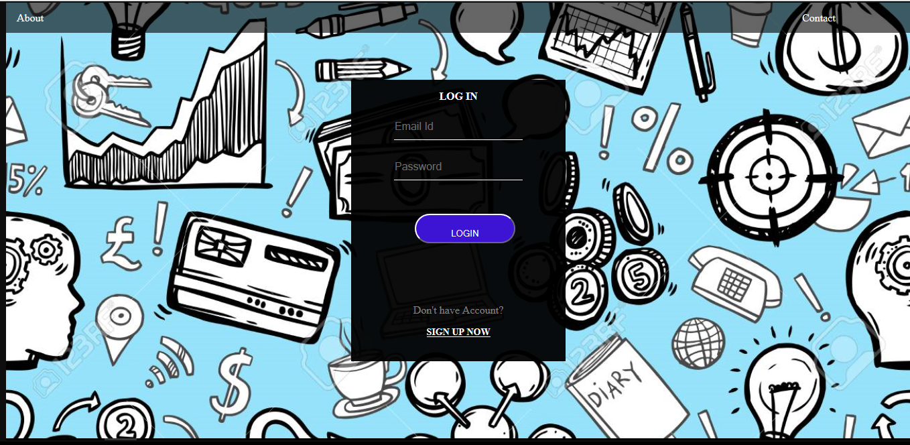

# Database Design

## Tables Structure

**Candidate:**

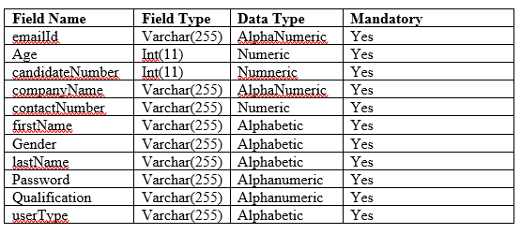

**Candidate Requirement:**

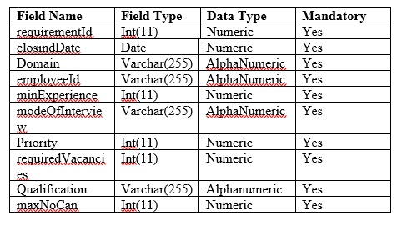

**Interview Schedule:**

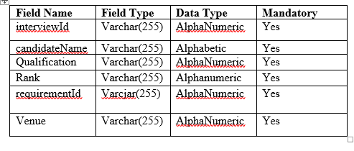

**Interview Observation:**

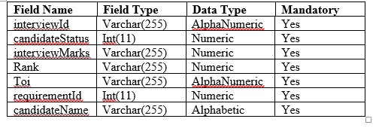

# Change Log

*Please note that this table needs to be maintained even if a Configuration Management tool is used.*

|  |  |  |  |  |
| --- | --- | --- | --- | --- |
| Version Number | Changes made | | | |
| V1.0 | *<First version>* | | | |
| V1.1 | *<If the change details are not explicitly documented in the table below, reference should be provided here>* | | | |
| Page no | Changed by | Effective date | Changes effected |
|  |  |  |  |
|  |  |  |  |
|  |  |  |  |
|  |  |  |  |
| V1.2 | *<If the change details are not explicitly documented in the table below, reference should be provided here>* | | | |
| Page no | Changed by | Effective date | Changes effected |
|  |  |  |  |
|  |  |  |  |
|  |  |  |  |
|  |  |  |  |